**Supplementary figures**



***Fig. S1. Effects of various concentrations of Po on the proliferation in lung bronchial epithelial cells.*** Cell proliferation was measured by use of a cell counting kit-8 assay after HBE and BEAS-2B cells were exposed to 0, 2.5, 5, 10, 20, or 50 μg/mL of Po for 24 or 48 h. The relative ratios of cell proliferation were determined by comparison with the proliferation of control cells (means ± SD, n = 3). (B) Cell proliferation was measured by 5-Ethynyl-2’-deoxyuridine (EdU) assays, and (C) quantitative analysis incorporation (means ± SD, n= 3). Bar=250 μm. \**P* < 0.05 difference from control cells.



***Fig. S2. The*** ***effect of Po on expressions of*** ***EMT-related transcription factors.*** (A and B) The protein levels of ZEB1, ZEB2, Slug, and Snai1 were determined (means ± SD, *n =* 3) in HBE and BEAS-2B cells exposed to 0 or 5 μg/mL of Po for 0, 10, 20, or 30 passages.(C and D) The protein levels of ZEB1, ZEB2, Slug, and Snai1 were determined (means ± SD, *n =* 3) in HBE and BEAS-2B cells exposed to 0 or 5 μg/mL of Po for 0, 3, 6, 12, or 24 h.



***Fig. S3. The efficiency of p65 knockout was assessed.*** After HBE and BEAS-2B cells were transfected with p65 siRNA or control siRNA for 24 h, they were exposed to 0 or 5 μg/mL of Po for 24 h.(A and B) The protein levels of p-p65 and p65 were determined (means ± SD, *n =* 3) for HBE and BEAS-2B cells. \**P* < 0.05 different from control cells; *#P*<0.05 different from Po-treated cells.



***Fig. S4. The efficiency of MALAT1 knockout was evaluated.*** After HBE and BEAS-2B cells were transfected with MALAT1 siRNA or control siRNA for 24 h, they were exposed to 0 or 5 μg/mL of Po for 24 h.The mRNA levels of MALAT1 were determined (means ± SD, *n =* 3) in HBE and BEAS-2B cells by qRT-PCR. \**P* < 0.05 different from control cells; *#P*<0.05 different from Po-treated cells.

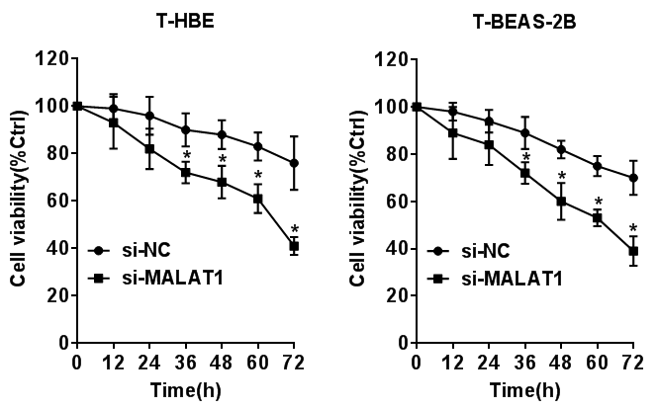

***Fig. S5. The effect of MALAT1 on cell viability.***

Knockdown of MALAT1 reduced the viability of Po-transformed HBE and BEAS-2B cells. *P < 0.05 different from cells transfected with si-NC.

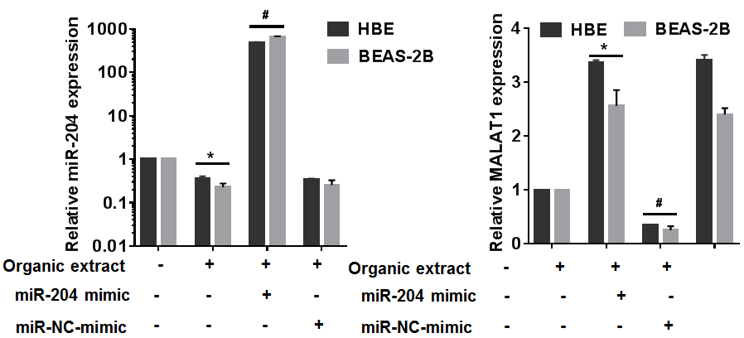

***Fig. S6. miR-204 regulated MALAT1 in lung bronchial epithelial cells exposed to Po.*** After HBE and BEAS-2B cells were transfected with an miR-204 mimic or an NC mimic for 24 h, they were exposed to 0 or 5 μg/mL of Po for 24 h.The mRNA levels of miR-204 and lncRNA MALAT1 were determined (means ± SD, *n =* 3) in HBE and BEAS-2B cells by qRT-PCR. \**P* < 0.05 different from control cells; *#P*<0.05 different from Po-treated cells.